Performance Coaching Pro Course
Application Form

Context of the application

Thank you for your interest in the Performance Coaching Pro Course – Level 5. Please complete the application form to the best of your ability, as it allows the selection panel to ascertain who will be best suited for the course. A follow up call may occur prior to a decision if more detail is required.

As a reminder the key dates are:
- 22nd May 2024: Application window opens.
- 24th June 2024: Application window closes at 09:00.
- 5th July 2024: Decisions will be communicated via email.
- 22nd – 26th July 2024: Individual Introduction Calls
- 13th August 2024: Introduction workshop (09:00 – 11:00)
- 7th – 10th Oct 2024: Workshop 1
- 27th – 30th January 2025: Workshop 2
- 22nd – 25th April 2025: Workshop 3
- 7th – 10th July 2025: Workshop 4
- 14th – 19th September 2025: Workshop 5
- 12- 14th January 2026: Transition Workshop
- Up to 6 weeks: Pro Transition Player Support (Dependant on current role)

Please download and complete the application form in full and send it to PerformanceCoachSupport@LTA.org.uk

Personal Details
Please do not leave any fields blank.

First Name | Last Name | Coach Code

Email | Contact Number

Why are you applying for this course and how do you hope this course can benefit you in the future? (200 words min)

Tell us about a time you received feedback on your coaching practice. Please detail how this came to be, what you learnt from this experience and how it shaped your future coaching practice. (200 words min)

Can you tell us a time where you struggled with a difference of opinion between you and another and how you managed to move through it? (200 words min)

Can you describe a time where you have collaboratively worked with others, sharing ideas and thoughts in a coaching context with player development in mind? (200 words min)

Describe a moment that led you to recognise how your own thoughts, emotions, and biases informed the way you work and the potential impact of this.

Can you tell us a time where you experienced a ‘problem’ regarding player development and/or coaching and reflect what you did and what you learnt from this experience?

How do you pursue your professional and coaching development? (200 words min)

Please explain how you will prioritise the course and your own development across the next 18 months?

Your Sponsor(s)
With the 24 days of workshops and associated work across 18 months it is a necessity to get an endorsement from your line manager of your suitability for the course and how they will support you / release you from your programme to ensure you can commit to all days.

Please get your sponsor to use the below text box to detail why you should be considered for the course and how they will support you whilst on the course. (200 words min)

Name of Sponsor(s): | Contact email:

Name of Sponsor(s):

Coaching Qualification Details
Please do not leave any fields blank.

Current Qualification Level |  | Awarding Body | Date Passed
Coach Accreditation
Please state with an ‘x’
Accredited + |  | Accredited | Not Accredited

Playing Level
Please fill in all the boxes below that are relevant to your playing level.
If you competed, please indicate at which level and if you did not compete, please indicate if you have a play test grade or rating.

Highest ever  ATP/WTA ranking  (singles) | Highest ever  ATP/WTA ranking  (doubles) | Competed  at  University  (Y/N) | Competed  at  National  Level  (Y/N) | Competed at County Level  (Y/N) | Highest ever rating | Play Test  Grade  (1/2/3) | Didn’t  Compete  (mark with an ‘x’)

Did you ever train in a performance programme?

YES (Please detail below) | NO

Current Role
What role do you have in your venue and how many hours do you work delivering coaching? Please specify for each different level of player you work with linked to the LTA Player Pathway (Embedded below).

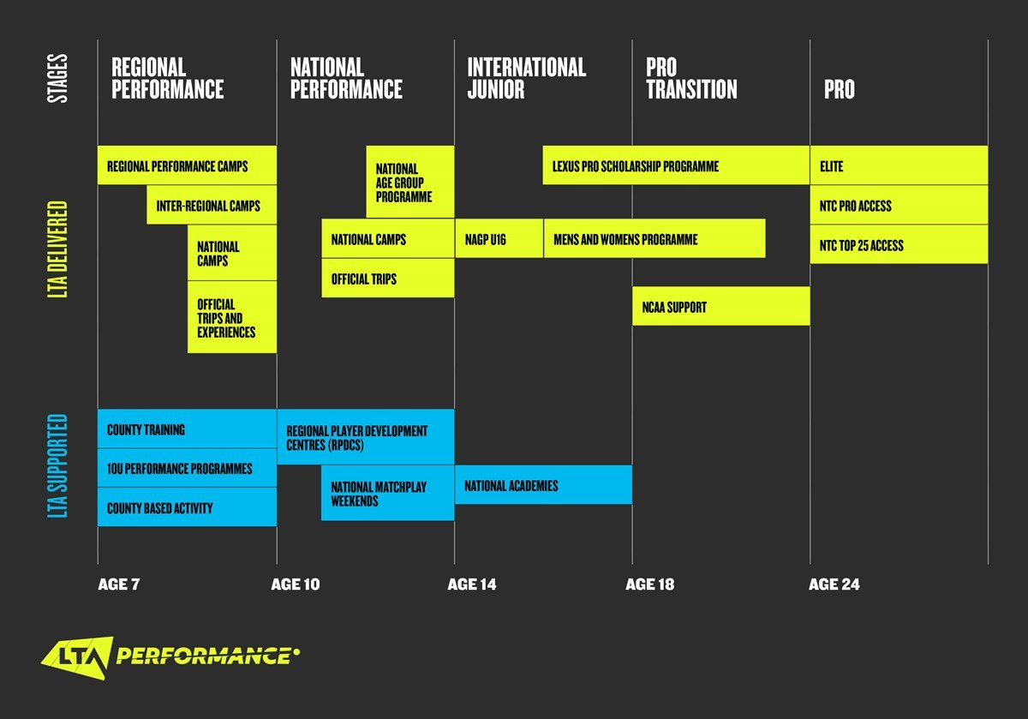

Role | Venue | How many hours you spend coaching per week | Level of Players  (Please use the LTA Player Pathway as a reference)

Which of these three statements best describes your current situation, please mark with an “x”

Currently working in the International Junior / Pro Transition / Pro stages |  | Has a player(s) on trajectory to be in the International Junior / Pro Transition / Pro stages | Aspires to work in the International Junior / Pro Transition / Pro stages

Please provide the names of any notable past or present players you’ve coached and indicate who you will be using as case studies throughout the course.

Player Name | Level  (Club/County/Regional/MWP/PSP Men’s and Women’s WTA/ATP ranking) | Past or Current

Availability
Commitment to all workshops is a necessity unless extenuating circumstances have been approved in advance of acceptance. Please mark with an “x” if you cannot make any workshops and explain your reasons for the selection committee to review.

Introduction Workshop | Workshop 1 | Workshop 2 | Workshop 3 |  | Workshop 4 | Workshop 5 | Graduation  Workshop | Pro Transition Player Support (up to 6 weeks)

Reasons for why you cannot make workshops. Please detail reasons for each instance.

Thank you for taking the time to apply, please send the application form to PerformanceCoachSupport@LTA.org.uk. We will be in touch shortly. The final decisions will be communicated on 5th July 2024 via email.

Performance Coach Education & Development team

